Contents
1 Database and DBMS design 2
1.1 Database Requirements 2
1.1.1 Scenario 2
1.1.2 Data Requirements 2
1.1.3 User and system requirements 2
1.2 Database Design 2
1.2.1 Conceptual model 2
1.2.2 Model mapping and logical design 2
1.2.3 Physical model 2
1.3 DBMS Architecture and Programming Techniques 3
1.4 Data Transfer 3
1.4.1 Flowchart and DFD 3
1.4.2 Evaluation of data transfer 3
1.5 Effectiveness of the database and DBMS 3
2 DBMS Development 3
2.1 SQL Queries 3
2.2 Data structures 3
2.3 Indexing 3
2.4 Criticizing the mapping of SQL queries 4
3 Concurrency Control (CC) 4
3.1 Standard DBMS CC Techniques 4
3.2 Implementation of CC 4
4 User Interface and Testing Plan 4
4.1 User Interface Development 4
4.2 Testing Plan 4
4.3 Evaluation 4
References 4

Database and DBMS design

Database Requirements

Scenario
Scenario
The university and business park contain multiple gates used daily by students, faculty, staff, tenant employees, and visitors. Each user belongs to a specific role such as Student, Faculty, or Tenant Employee, and may register one or more vehicles. Tenant employees work for a company located in the business park, while HTU users may not belong to any company.
The system defines access rules and schedules that determine which roles can use which gates and at what times. When a vehicle approaches a gate, the system identifies the vehicle, checks the owner’s role and company, and decides whether to grant or deny access. Every attempt is stored as an access log, allowing the university and business park to manage security, vehicle movement, and accurate records.
Extended Scenario
The university and business park contain several gates, each controlling vehicle entry into specific areas.
Each gate has a GateID, GateName, and GateType. Gates regulate daily access for students, faculty, staff, tenant employees, and visitors.
The system manages multiple companies located in the business park.
Each company has a CompanyID, CompanyName, Phone, and Email.
A company can employ many users, and each tenant employee user belongs to at most one company.
Users are classified by roles that define their access permissions.
Each role has a RoleID, RoleName, and Description.
Every user belongs to exactly one role.
Each user record includes a UserID, FullName, SSN, Email, Phone, RoleID, and CompanyID.
Users may register one or more vehicles, and each vehicle belongs to exactly one user.
Each vehicle has a VehicleID, LicensePlate, Make, Model, Color, VehicleType, IsActive, and UserID.
Only active vehicles are considered valid for gate access checks.
The system defines access rules that connect roles to gates and time windows.
Each access rule has an AccessRuleID, IsActive, Priority, RoleID, GateID, and ScheduleID.
Access rules state which roles may use which gates under which schedules.
Access schedules describe allowed time periods.
Each schedule has a ScheduleID, ScheduleName, DaysOfWeek, StartTime, and EndTime.
Schedules can represent patterns such as weekday daytime access or 24/7 access.
When a vehicle approaches a gate, the system reads the license plate, retrieves the corresponding vehicle and user, determines the user’s role and checks for an active access rule whose schedule permits access at that time. If such a rule exists, the gate opens.
Each attempt is recorded in an access log.
Each log entry has an AccessLogID, AccessTime, Result, VehicleID, and GateID.
Access logs capture both successful and denied attempts and provide the security team with detailed information for monitoring, auditing, and analyzing vehicle movement across the university and business park.

Data Requirements
- The system keeps a list of companies that operate inside the business park (company name and basic identification details).
- The system keeps a list of user roles (for example: student, staff, security, tenant employee), because permissions depend on role.
- The system stores users (people who can request access).
  - Each person has one role.
  - Some people belong to a company (tenant employees), while others may have no company (university users).
  - Each person has identifying information such as name and a unique number (and optional details like SSN/contact info if used in the project).
- The system stores vehicles that are registered in the system.
  - Each vehicle belongs to one person.
  - A person may register more than one vehicle.
  - Vehicles have unique identifiers (like plate number) and may have extra details (model, color, etc.).
  - A vehicle can be marked active/inactive; inactive vehicles should not be allowed through gates.
- The system stores gates (each gate has an ID and description/name/type/location details as needed).
- The system stores time schedules that describe when access is allowed (days of week + start/end times, or 24/7).
- The system stores access permissions (rules) that decide who can enter from which gate and at what times.
  - A rule links a role to a gate and a time schedule.
  - Rules can be enabled/disabled.
  - If multiple rules could apply, the system should follow a consistent rule priority/selection method.
- Every time a vehicle tries to pass through a gate, the system records an access log.
  - The record includes which vehicle, which gate, date/time, and whether access was granted or denied.
  - The reason/result should be clear enough to support security review (e.g., “not registered”, “outside allowed time”, “no permission for this gate”, etc.).
- The system must prevent inconsistent data, for example:
  - You cannot register a vehicle for a person that does not exist in the system.
  - You cannot assign a person to a role that does not exist.
  - You cannot create a permission rule for a gate or schedule that does not exist.
  - Unique IDs (like company IDs, role IDs, user IDs, gate IDs, schedule IDs) must not repeat.

User and system requirements
The users
- Administrator
- Gate security
- Drivers (students/ employees)
Interactions with the system
- Administrator
  - Add, update, and remove records for companies, roles, users, vehicles, gates, schedules, logs and access rules.
  - View/search all stored data and verify it is correct
  - Review access attempts and export or view access logs when needed.
- Gate security
  - Enter a vehicle identifier and the gate being used.
  - Get an immediate response: access granted/denied, with a clear reason if denied.
  - View recent access attempts for a specific gate or vehicle
- Drivers (students/ employees)
  - Provide their details for registration and register their vehicles.
  - May need to update vehicle information
system requirements
- Correctness and integrity
  - IDs must be unique (no duplicate user IDs, vehicle IDs, and so on).
  - The system must prevent invalid links (no vehicle stored for a non-existing user).
  - Access decisions must follow the same logic every time (consistent rule evaluation).
- Security
  - Only authorized users (admin) can change stored data.
- Usability
  - Menu-driven interface with clear prompts and error messages.
  - Search and listing options for fast lookup (by ID).
- Performance
  - Fast access checks at the gate (quick lookup for vehicles and matching rules).
  - Efficient searching for logs and tables.
- Reliability & persistence
  - Data must be saved to files and loaded correctly after restart.
  - The system should handle missing/corrupted files gracefully (fail safely with messages).
- Auditability
  - Every access attempt should be recorded with time, gate, vehicle, and decision.
  - Logs should support later review and reporting.

Database Design

Conceptual model
The conceptual model is a high-level representation of the data required by the system. It shows the main parts of the system and how they are connected to each other.
Goal of the conceptual model
- To give a clear understanding of the system’s data structure.
- To show how different parts of the system are related.
Components of the conceptual model
- Entities
- Relationships
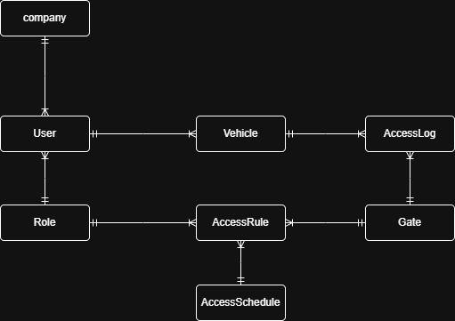
Description of the figure
- A company can be linked to many users, while each user belongs to at most one company.
- Each user has exactly one role, which defines their permissions.
- A user can register one or more vehicles, and each vehicle belongs to one user.
- Access rules connect roles to specific gates and define when access is allowed using an access schedule.
- An access schedule defines the allowed time periods for access.
- Every time a vehicle tries to pass through a gate, an access log entry is created to record the event.

Model mapping and logical design
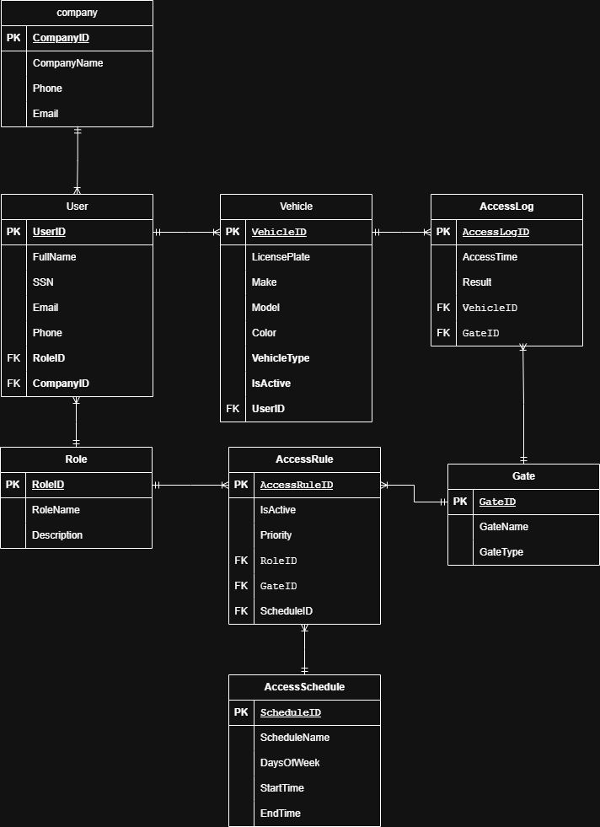
In this stage, the conceptual model is mapped into a logical design by converting each main part of the system into a table. Each table has a primary key to uniquely identify records, and foreign keys are used to connect related tables (for example: vehicles belong to users, and access rules connect roles, gates, and schedules).
Database schema (after mapping)
Company
- Company (CompanyID, CompanyName, Phone, Email)
Role
- Role (RoleID, RoleName, Description)
User
- User (UserID, FullName, SSN, Email, Phone,
RoleID FK → Role (RoleID),
CompanyID FK → Company (CompanyID))
Vehicle
- Vehicle (VehicleID, LicensePlate, Make, Model, Color, VehicleType, IsActive,
UserID FK → User (UserID))
Gate
- Gate (GateID, GateName, GateType)
AccessSchedule
- AccessSchedule (ScheduleID, ScheduleName, DaysOfWeek, StartTime, EndTime)
AccessRule
- AccessRule (AccessRuleID, IsActive, Priority,
RoleID FK → Role (RoleID),
GateID FK → Gate (GateID),
ScheduleID FK → AccessSchedule (ScheduleID))
AccessLog
- AccessLog (AccessLogID, AccessTime, Result,
VehicleID FK → Vehicle (VehicleID),
GateID FK → Gate (GateID))

Physical model
The Gate Access and Vehicle Authorization System is implemented in the physical design of this database by eight relational tables, that is, Company, Role, User, Vehicle, Gate, AccessSchedule, AccessRule and AccessLog. Data consistency and accuracy are ensured by defining each table in an explicit data type, primary key, foreign key and constraints.

The identifiers are held as integer primary keys to uniquely identify all records as well as to make efficient reference between tables. Variables including names, emails, license plates and descriptions are stored with variation to VARCHAR with the right length restriction. Time based information is saved with the help of TIME and DATETIME which can store access schedules and gate access events accurately.

Tables are enforced on relationships through foreign keys. Users are associated to roles to identify the permissions of the user and optionally associated to companies to identify the tenants of the business park. Mobiles are attached to the users to make sure that there is a legitimate owner of the vehicle. The roles, gates, and schedules are linked using the access rules that enable the system to know whether a vehicle is authorized to pass through a particular gate at a particular time. Each attempt of the gate access is captured in the access log that associates the incident with the vehicle and the gate to audit and security purposes.

The integrity of data is implemented through the mandatory fields (NOT NULL) and values (UNIQUE) of emails, license plates, role names and gate names. Such limitations deny the possibility of assigning the same names to different members and maintain the integrity of all important identifying data across the system.

These physical design helps to provide the effective access authorization, the stable storage of the operational data and the complete traceability of the access attempts such a good basis of the system implementation.
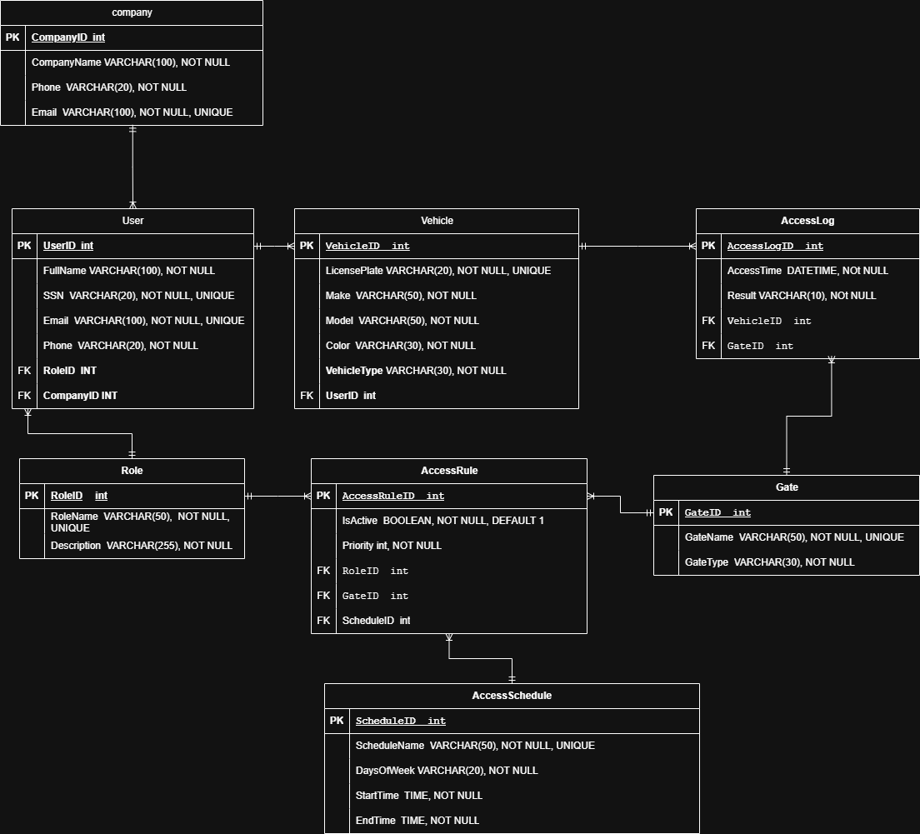
Table Name | Description
Company | Purpose: Stores business park companies.  Stored info: CompanyID (PK, INT) uniquely identifies each company; CompanyName (VARCHAR(100), NOT NULL) ensures every company has a name; Phone (VARCHAR(20), NOT NULL) required contact; Email (VARCHAR(100), NOT NULL, UNIQUE) prevents duplicate company emails and supports communication.  PK: CompanyID.  FKs: None.
Role | Purpose: Stores the different roles used to control permissions (e.g., student, staff, tenant employee).  Stored info: RoleID (PK, INT); RoleName (VARCHAR(50), NOT NULL, UNIQUE) ensures no duplicate role names; Description (VARCHAR(255), NOT NULL) explains what the role is.  PK: RoleID.  FKs: None.
User | Purpose: Stores people who can register vehicles and request gate access.  Stored info: UserID (PK, INT); FullName (VARCHAR(100), NOT NULL); SSN (VARCHAR(20), NOT NULL, UNIQUE) ensures each person is uniquely identified; Email (VARCHAR(100), NOT NULL, UNIQUE) avoids duplicates; Phone (VARCHAR(20), NOT NULL).  PK: UserID.  FKs: RoleID → Role(RoleID) links each user to one role (needed for permission decisions). CompanyID → Company(CompanyID) links tenant employees to their company.
Vehicle | Purpose: Stores vehicles registered in the system for gate access validation.  Stored info: VehicleID (PK, INT); LicensePlate (VARCHAR(20), NOT NULL, UNIQUE) prevents duplicate registration of the same plate; Make/Model (VARCHAR(50), NOT NULL); Color (VARCHAR(30), NOT NULL); VehicleType (VARCHAR(30), NOT NULL) helps classification;  PK: VehicleID.  FKs: UserID → User(UserID) ensures every vehicle belongs to an existing user.
Gate | Purpose: Stores gates that vehicles can attempt to pass through.  Stored info: GateID (PK, INT); GateName (VARCHAR(50), NOT NULL, UNIQUE) prevents duplicate gate names; GateType (VARCHAR(30), NOT NULL) describes the gate category.  PK: GateID.  FKs: None.
AccessSchedule | Purpose: Defines the allowed days and time windows for access.  Stored info: ScheduleID (PK, INT); ScheduleName (VARCHAR(50), NOT NULL, UNIQUE) for easy identification; DaysOfWeek (VARCHAR(20), NOT NULL) stores allowed days; StartTime (TIME, NOT NULL) and EndTime (TIME, NOT NULL) define the time range.  PK: ScheduleID.  FKs: None.
AccessRule | Purpose: Stores permission rules that decide which roles can access which gates and when.  Stored info: AccessRuleID (PK, INT); IsActive (BOOLEAN, NOT NULL, DEFAULT 1) allows enabling/disabling rules; Priority (INT, NOT NULL) supports choosing between multiple possible rules.  PK: AccessRuleID.  FKs: RoleID → Role(RoleID) (permission based on role), GateID → Gate(GateID) (permission tied to a specific gate), ScheduleID → AccessSchedule(ScheduleID) (permission limited by time schedule).
AccessLog | Purpose: Records every access attempt for auditing and security tracking.  Stored info: AccessLogID (PK, INT); AccessTime (DATETIME, NOT NULL) records when the attempt occurred; Result (VARCHAR(10), NOT NULL) stores outcome (e.g., GRANTED/DENIED); VehicleID (FK) and GateID (FK) link the attempt to the specific vehicle and gate.  PK: AccessLogID.  FKs: VehicleID → Vehicle(VehicleID) and GateID → Gate(GateID) so each log entry is traceable to what happened and where.

DBMS Architecture and Programming Techniques
- Storage
What this component represents
The storage component represents the lowest level of the DBMS architecture, where all database data is permanently stored. Its main role is to ensure that data is preserved even after the system terminates or restarts.
Responsibilities
- Maintain persistent copies of all database tables.
- Store data in a structured and readable format.
Implementation in this project
in this DBMS I used a CSV files as a storge each table has its own CSV file.
- Storage Manager
What this component represents
The storage manager is the DBMS component responsible for managing all interaction between the DBMS and the storage layer. It acts as a bridge between the in-memory data structures and the persistent files.
Responsibilities
- Detect whether a table file exists and create it if necessary.
- Load table data from CSV files into memory at system startup.
- Save updated data back to CSV files after insert, update, or delete operations.
- Ensure that data is written in a consistent and structured format.
- Handle file-related errors safely.
Programming techniques used
- File handling in C using standard I/O functions (fopen, fclose, fgets, fprintf).
- Parsing CSV records into structured in-memory data using string processing functions.
Implementation choice in this project
The create load and save functions.
- Buffers (In-memory Data Area)
What this component represents
Buffers represent the main-memory area where data is temporarily stored while the DBMS is running. Instead of accessing the storage layer (disk/files) for every operation, the DBMS works on data that has already been loaded into memory. This significantly improves performance and simplifies processing.
Responsibilities
- Hold copies of table data while the program is executing.
- Allow fast read and write operations without constant disk access.
- Serve as the working area for all CRUD operations.
Implementation in this project
In this DBMS implementation, buffers are realized as in-memory data structures, not fixed-size pages. When the system starts:
- Data is loaded from CSV files into memory.
- Each table is stored entirely in memory until the program ends.
- All operations (search, insert, update, delete) operate directly on this in-memory data.
The data is created by structs.
- Buffer Manager
What this component represents
The buffer manager is responsible for managing the buffers, deciding when data is loaded into memory and when it is written back to storage.
Responsibilities
- Load data from storage into memory at startup.
- Keep in-memory data synchronized with persistent storage.
- Decide when modified data should be written back to disk.
- Coordinate with the storage manager to perform read/write operations.
Programming techniques used
- Dynamic memory allocation (malloc, free) to create in-memory structures.
- Pointer-based data access for efficient traversal and updates.
- Index, File, and Record Manager
What this component represents
The index manager is responsible for speeding up record access by providing fast lookup mechanisms, avoiding full table scans.
Responsibilities
- Maintain indexes for fast search.
- Insert index entries when new records are added.
- Remove index entries when records are deleted.
- Keep indexes consistent with table data.
Implementation in this project
This DBMS uses hash-based indexing for fast record lookup. For each main table, a hash table is maintained that maps a key (such as ID or license plate) to the corresponding record node.
The index uses:
- Fixed-size hash tables
- A hash function based on the record key
- Linear probing for collision handling
- Dummy (tombstone) markers for safe deletion
This allows fast O(1) average-time lookups.
Programming techniques used
- Arrays of pointers
- Hash functions
- Linear probing collision resolution
- Tombstone handling for deleted entries

- Query Compiler
What this component represents
In a full DBMS, the query compiler is responsible for:
- Parsing high-level queries (such as SQL).
- Checking syntax and semantics.
- Translating queries into an internal execution plan.
Implementation in this project
A full SQL query compiler is not implemented in this DBMS. Instead:
- User requests are issued through a menu-driven interface.
- Each menu option directly corresponds to a predefined operation (add user, register vehicle, check access).
This design choice simplifies the system while still allowing controlled interaction with the database.
Programming techniques used
- Function-based mapping between menu options and operations.
- Input validation before execution.

- Execution Engine
What this component represents
The execution engine is responsible for carrying out database operations after they have been defined or selected. It coordinates with lower DBMS components to access records, apply rules, and update storage.
Responsibilities
- Execute CRUD operations.
- Enforce business rules and data constraints.
- Use indexes to locate records efficiently.
- Interact with the storage and buffer managers to read and write data.
- Trigger logging for data modifications and access attempts.
Implementation in this project
In this DBMS, the execution engine is implemented as a set of modular C functions, each responsible for a specific operation. These functions:
- Call the record manager to create, update, or delete records.
- Use hash indexes for fast record lookup.
- Validate foreign key relationships and constraints.
- Write changes back to storage through the storage manager.
- Generate audit and access log entries when required.
Programming techniques used
- Modular function design
- Structured control flow
- Pointer-based data access
- Reuse of shared validation and helper functions

- Transaction Manager
What this component represents
The transaction manager is the DBMS component responsible for controlling database operations as transactions and ensuring that they follow the ACID properties: Atomicity, Consistency, Isolation, and Durability. These properties guarantee that database operations are executed reliably and that the database remains in a correct state even in the presence of failures or multiple operations.
- Atomicity
Atomicity ensures that a database operation is treated as a single unit of work. This means that the operation is either completed fully or not applied at all, preventing partial or incomplete changes to the database.
- Consistency
Consistency ensures that every transaction moves the database from one valid state to another. All integrity rules and constraints must be satisfied before and after the operation.
- Isolation
Isolation ensures that transactions do not interfere with each other. The result of one transaction should not be affected by other concurrent transactions that are executing at the same time.
- Durability
Durability guarantees that once a transaction is completed, its effects are permanently stored. Even in the event of a system crash, the committed changes remain available.

Responsibilities
- Group database operations into transactions.
- Ensure that either all operations in a transaction succeed or none are applied.
- Coordinate with concurrency control and logging components.
- Handle commit and rollback decisions.
Implementation in this project
this part was implemented in another way that combine the logging component and the concurrency component.
- Logging
What this component represents
Logging records changes and important events in the database so that actions can be traced and, in advanced systems, undone or redone during recovery.
Responsibilities
- Record database changes.
- Maintain a history of modifications.
- Support auditing and accountability.
- Provide the foundation for recovery mechanisms.
Implementation in this project
This DBMS implements an audit log to record every operation done into the system:
Programming techniques used
- Append-only file writing
- Structured log records using C structs

- Recovery
What this component represents
Recovery ensures that the database can be returned to a consistent state after failures such as crashes or power loss.
Responsibilities
- Undo incomplete operations.
- Redo committed operations after failure.
- Restore consistency using logs.
Implementation in this project
This DBMS has a backup method to copy all the CSV files into backup CSV files to avoid problems. The type of backup done is a full backup for all the data every time.

- Data Definition Language (DDL)
What this component represents
The Data Definition Language (DDL) component is responsible for defining the structure of the database, including tables, attributes, data types, and constraints.
Implementation in this project
A traditional SQL-based DDL compiler is not implemented.
- Concurrency Control
What this component represents
Concurrency control ensures that simultaneous database operations do not lead to inconsistent or corrupted data. It enforces isolation between transactions and preserves database correctness.
Implementation in this project
Concurrency control is designed and implemented.
The design follows the shared (S) and exclusive (X) locking model:
- Read operations require shared locks.
- Write operations require exclusive locks.
- Conflicting operations must wait until locks are released.
This design provides a clear foundation for future multi-threaded execution.
Programming techniques referenced
- Lock-based access control model
- Prepared use of threads (pthread)
Implementation in this project
Concurrency control was implemented in this project in a simulation based function that show how it will work with the locks (S/X).
- Lock Table
What this component represents
The lock table is a data structure used to track active locks on database objects. It records which transaction holds which lock and prevents conflicting operations from executing simultaneously.
Implementation in this project
Lock table will have:
- Store lock entries for database objects (tables or records).
- Record lock type (shared or exclusive).
- Maintain waiting and execution queues.
Programming techniques planned
- Struct-based lock entries
- Mutexes for thread synchronization
Implementation in this project
Locks were implemented in this project to help in the concurrency control operate based on S and X locks.

Data Transfer

Flowchart and DFD
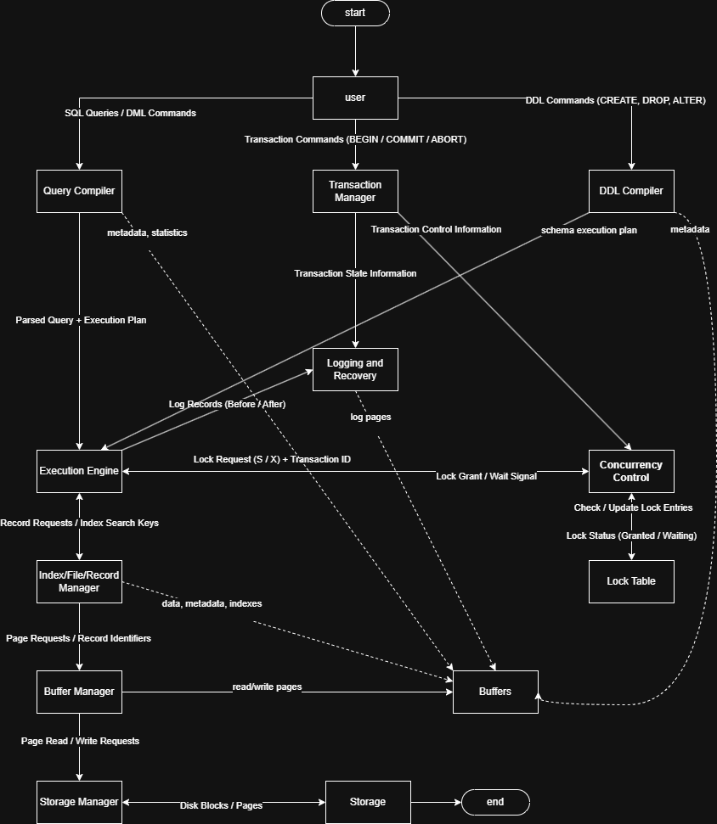
The Data Flow Diagram (DFD) illustrates how queries, transaction commands, metadata, data pages, and log records move through the DBMS components. User queries and updates are processed by the query compiler and executed by the execution engine, while DDL commands are handled by the DDL compiler and executed through the same execution path on metadata. Transaction management coordinates concurrency control and logging to ensure ACID properties. Data access is performed through the index, buffer, and storage managers, with buffers acting as in-memory data structures. Dashed arrows represent data-only flows such as metadata, statistics, and log pages, while solid arrows represent both control and data flow.

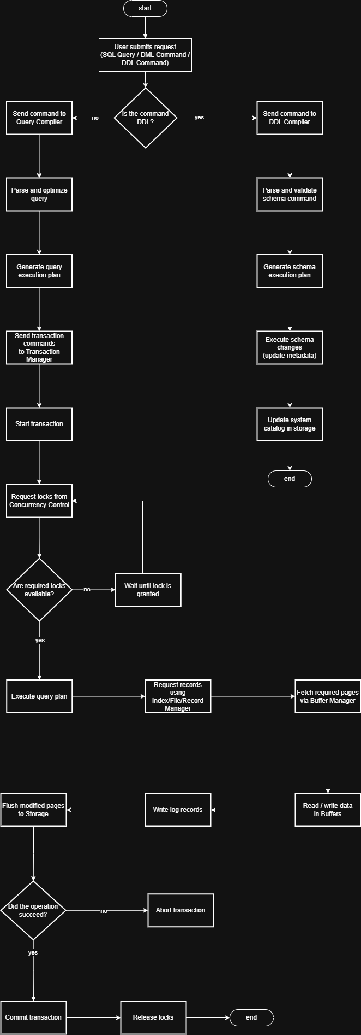
The flowchart illustrates the process by which the database system completes step by step upon receiving a request by a user. The process begins as the user enters a command, this may be one of the SQL query, DML command or a DDL command. First, the system examines the type of the command to determine the direction to take.
In case the command is a DDL command, then it is sent to the DDL compiler. The DDL compiler interpret and check the schema command and generate a schema execution plan. Subsequently, the system will make the schema changes and update the metadata and system catalog in storage. Once the schema update has been completed, the process is terminated.
When the command is not a DDL it is considered a DML operation. This command will be forwarded to query compiler where query will be optimized and compiled and a query execution plan will be created. Once the plan is prepared, the transaction manager initiate a new transaction in order to manage the execution of the operation.
The transaction manager requests the necessary locks of the concurrency control component. In case the locks are not provided, the transaction will be put on hold until the locks have been obtained. Upon the availability of the locks, the query plan is executed by the execution engine. The index/ file/ record manager gets the records needed and the buffer manager gets the pages required and loads the data into the buffers where it is read or written.
At execution, the log records are recorded to trace any changes and the altered pages are also flushed to storage to ensure the information is stored. Finally, the system would check whether the operation was successful. In the event of failure, the transaction will be aborted and otherwise the transaction is committed. Lastly, the locks are all released and the process terminated.

Evaluation of data transfer
The data transfer between the different DBMS components is generally effective and well organized. The architecture allows data to move in a clear and structured way from one component to another, which helps the system work correctly and efficiently. Each component has a specific role, and the data passed between them is suitable for that role, such as queries, execution plans, metadata, pages, and log records.
The separation between query processing, transaction management, concurrency control, and storage management improves the clarity of data transfer. For example, queries are first handled by the query compiler and then passed as execution plans to the execution engine, instead of sending raw user input directly to lower-level components. This reduces errors and makes the flow of data more controlled. Also, metadata and statistics are transferred separately using data-only paths, which helps optimization without interfering with normal execution.
The use of buffers as an intermediate layer between memory and storage makes data transfer more efficient. Instead of reading and writing data directly from disk for every operation, data is first transferred into buffers where it can be accessed faster. This reduces disk access and improves overall performance. The buffer manager plays an important role in coordinating this transfer and keeping data consistent.
Data transfer related to transaction processing is also well handled. Transaction state information, lock requests, and log records are clearly passed between the transaction manager, concurrency control, logging and recovery components. This ensures that operations are executed safely and that changes can be recovered in case of failure. Overall, the DBMS architecture supports reliable and structured data transfer between components, although the process involves many steps which can add some overhead, especially in complex transactions.

Effectiveness of the database and DBMS
The database and DBMS design is effective in meeting the defined user and system requirements, as it was designed with correctness, security, usability, performance, reliability, and auditability in mind. The architecture and database structure support the main functional goals of the system while following core DBMS principles.
In terms of correctness and integrity, the system performs well. Unique identifiers are enforced for all main data items such as users, vehicles, gates, and logs, which prevents duplicate records from being stored. Validation checks ensure that invalid relationships are not allowed, for example a vehicle cannot be stored for a non-existing user. In addition, access decisions are evaluated using a fixed set of rules and schedules, which ensures that the same input always produces the same decision, maintaining consistency across the system.
Regarding security, the system is effective for its intended scope. Only an administrator user is allowed to modify stored data, which reduces the risk of unauthorized changes. By limiting write operations to a single trusted role, the system maintains control over critical database operations, although this also limits flexibility in multi-user scenarios.
The usability of the system is also strong. The menu-driven interface provides clear prompts and feedback, making it easier for the user to interact with the database without needing SQL knowledge. Search and listing operations based on identifiers allow fast lookup of records, which improves the overall user experience, especially when working with larger tables.
From a performance perspective, the DBMS is reasonably effective. Fast access checks at the gate are supported through efficient searching mechanisms, such as indexed lookups, which reduce the time needed to match vehicles and access rules. Searching logs and tables is also efficient compared to full sequential scans, although performance may decrease as the database grows due to the file-based storage approach.
In terms of reliability and persistence, the system meets the requirements well. Data is stored in files and correctly loaded after system restart, ensuring persistence. The system also handles missing or corrupted files in a safe way by displaying error messages instead of crashing, which improves robustness and reliability.
Finally, the system performs very well in terms of auditability. Every operation done to the system is recorded in an audit log to make sure every thing is correct and keep the integrity of the files. This makes the system suitable for environments where traceability is important.
Overall, the database and DBMS design is effective and well aligned with the defined requirements. While the system has some limitations, such as simplified concurrency handling and scalability constraints, it successfully satisfies the functional and non-functional requirements for the intended use case and provides a solid foundation for future improvements.

DBMS Development

SQL Queries
The system implements a custom Database Management System where standard SQL commands (INSERT, SELECT, UPDATE, DELETE) are mapped to specific C functions. These functions manage data persistence using CSV files, in-memory linked lists for traversal, and Hash Tables for efficient indexing.
Insert query
What I did for the insert was simple, but it was fully calculated with validations so the insert could not be wrong at all.
Here is an image for the insert function I have.
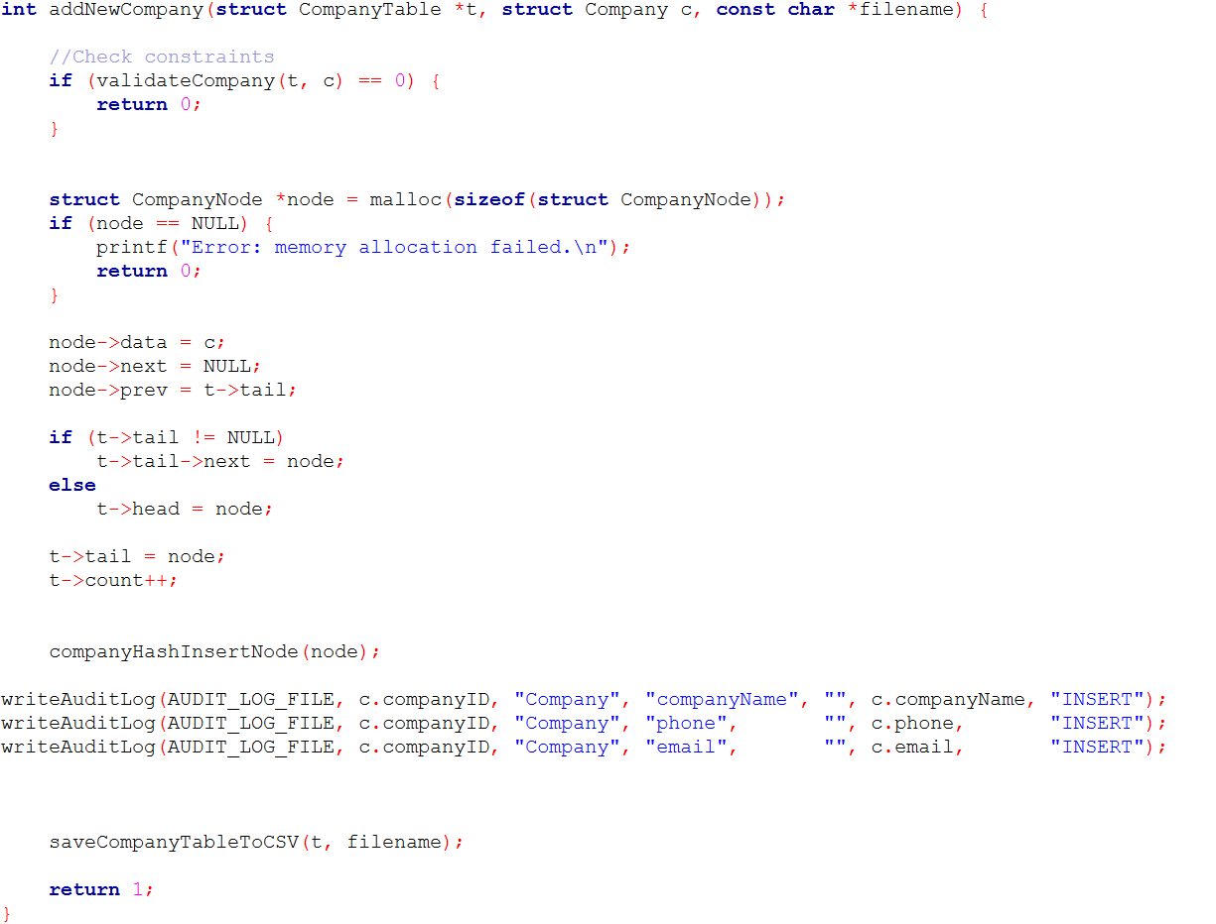
It shows a validate function first checked if it return false the insert will not work
Select query
The select query was implemented in an easy way, I chose to do a select all query as doing the other queries will take more time and effort where the select all can do same job.
Here is an image of the implementation.
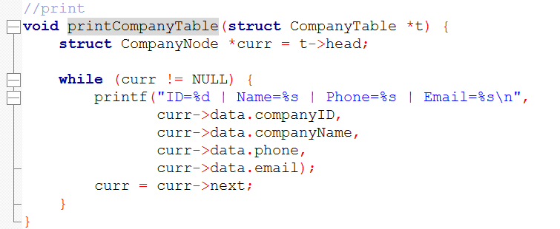
It’s a simple loop to run for all the recodes in the CSV file.
Update query
My way of implementing the update query was to edit the full row if you only need to change one column you have to repeat the same data that was in the recode and only change the one you want to change.
Here is an image to the function.

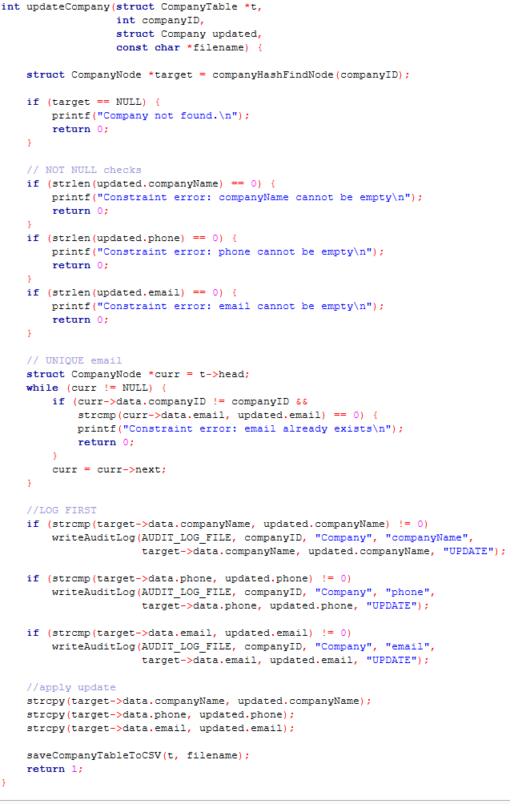
Delete query
The delete implementation I did was to fully remove the record based on the id that was entered.
Here is an image of the implementation.
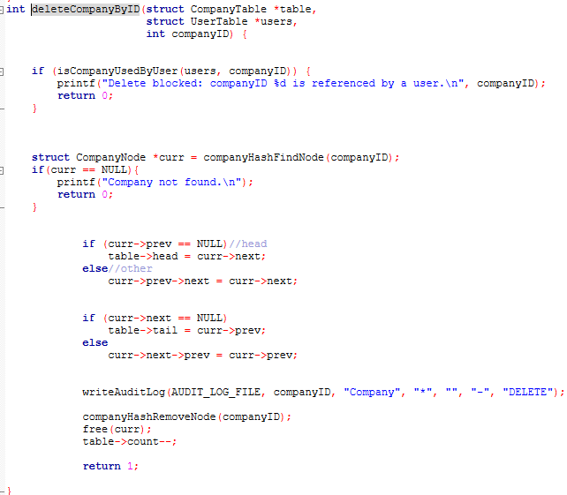
Also the constraints of the foreign keys are applied for simplicity it is on delete restrict.

Overall
the behaviour of real database for all the CRUD operations were met. PK, FK, NOT NULL, UNIQUE, RESTRICT.

Data structures
The dynamic data structure I used for this project was linkedLists. The idea of having a dynamic data structure that we do not have to reserve a spot in the system in advance, as it is allocated dynamically while the data is getting loaded from the files.
The tables are represented by a structure that contains:
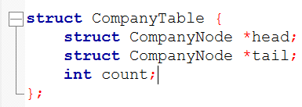
- Pointer for the head.
- pointer for the tail.
- counter.
The individual record is represented as structure using doubly linkedList
the structure contains:
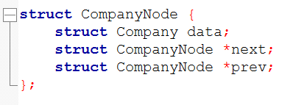
- the actual data.
- Head pointer.
- Tail pointer.
Memory for each node is allocated dynamically using malloc when:
- data is loaded from a CSV file at program startup
- a new record is inserted into a table
These linked-list-based structures act as the buffers in the DBMS architecture, allowing fast access and modification of records without constant disk access.

Implementation of the Buffer Manager
The buffer manager in this DBMS is implemented in a simplified way compared to a full DBMS. Instead of managing fixed-size pages, the buffer manager keeps entire tables in memory during execution.
The buffer management process works as follows:
- When the program starts, all database tables are loaded from their corresponding CSV files into memory.
- Each table is stored as a dynamically allocated linked list of records.
- All CRUD operations (insert, update, delete, search) operate directly on these in-memory structures.
- This reduces disk I/O and improves performance during execution.
The buffer manager relies heavily on pointer-based access and dynamic memory allocation to efficiently traverse and update records. Since all data is already in memory, searching and updating records is faster than reading from files for every operation.
Implementation of the Storage Manager
The storage manager is responsible for persistent data storage and ensuring that data is not lost when the program terminates. In this DBMS, persistence is implemented using CSV files, with one file per database table.
The storage manager performs the following tasks:
- File initialization
  - When starting the system, the system verifies the existence of every table file.
  - If a file does not exist, it is created and loaded with a CSV header that defines the table schema.
- Loading data at program start
  - Each CSV file is opened.
  - Records are read line by line.
  - The lines are interpreted and mapped to the respective record structure.
  - A new node is dynamically allocated using malloc.
  - The node is inserted into the table’s linked list.
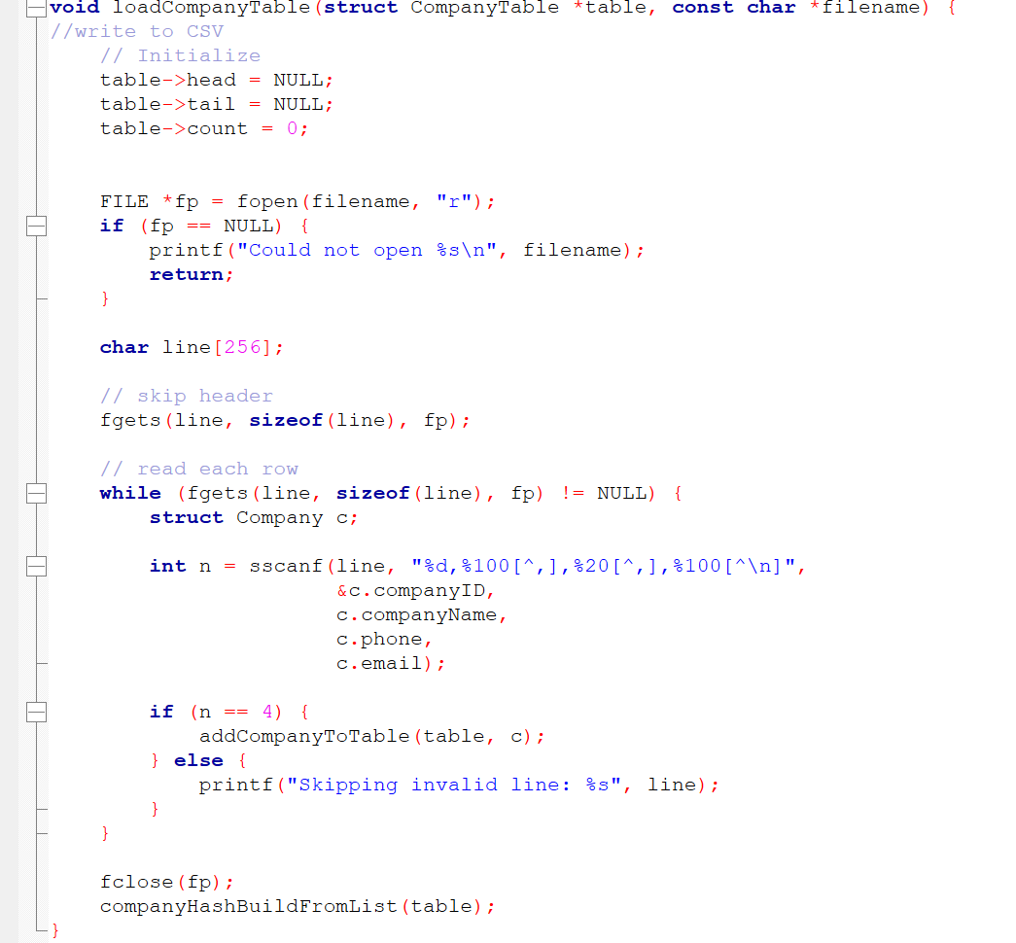
- Saving data after modifications
  - Upon insert, update or delete, the storage manager write the current state of the in-memory table to the CSV file.
  - This guarantees that changes are permanently stored.
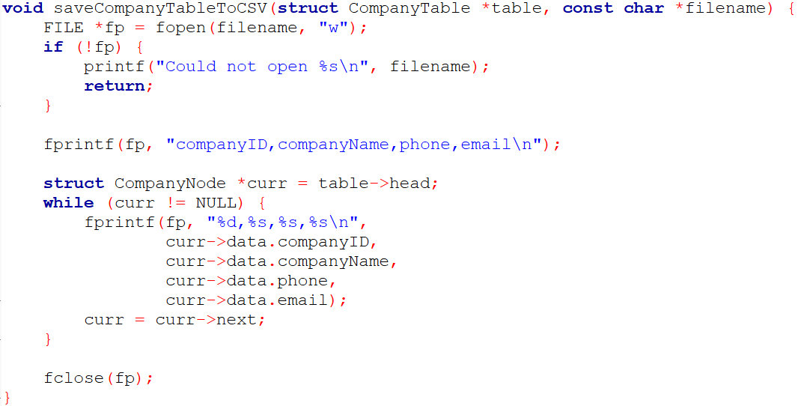
- Error handling
  - The storage manager checks for file access errors.
  - When a file is not opened or is lost, an error message is displayed on the system rather than failure.

- Persistence and data durability
Because data is stored in files and reloaded at the beginning of the program:
- The contents of the databases remain even after the termination of the program.
- The system can recover its state when restarted.
- The DBMS satisfies the requirement for reliable and durable storage.
Overall, the combination of dynamic in-memory data structures and file-based storage provides an effective balance between performance and persistence for the scope of this project.

Indexing
The indexing technique used in this DBMS is hash indexing with open addressing and linear probing. A hash table of each main table of the database (Company, User, Vehicle, Gate, AccessRule and logs) is stored in the memory. Every hash table is associated with a value of a primary key and the corresponding record node in the linked list.
The hash tables are implemented as fixed-size arrays of pointers. A hash function is applied to the primary key to compute an index position in the array. To determine a position in the array, a hash algorithm is used to compute the key of the primary key. In case of collision (calculated position is occupied) the system employs linear probing to locate the next available slot. This continues until an empty slot or the correct key is found.
The deletion is supported by the use of dummy (tombstone) markers in order to maintain the sequence of the probe. By removing a record, the hash record is not cleared entirely but instead the record is overwritten with a dummy record. This makes it possible to continue searching the hash table correctly in the future.
How indexing improves query performance
- INSERT
Before inserting a new record, the hash index is checked to ensure that the primary key does not already exist.
- UPDATE
The target record is found quickly using the index, allowing updates to be applied efficiently.
- DELETE
The record is located through the index and then safely removed from the linked list, while the hash index is updated using a dummy marker.
Overall, the implemented hash-based indexing technique is effective for optimizing the performance of the simulated SQL queries. It significantly reduces search time, enforces SQL-like constraints efficiently, and integrates well with the linked-list-based storage structure. For the scope of this project, this indexing approach provides a good balance between simplicity and performance.

Criticizing the mapping of SQL queries
The process of mapping SQL queries to CRUD statements in the developed DBMS is generally successful in achieving SQL-like behavior (e.g., rejecting duplicate primary keys, validating foreign keys, and enforcing constraints). However, compared to real DBMS execution of SQL, the mapping has limitations in flexibility, efficiency, and correctness guarantees in complex cases. The current approach relies on predefined functions and menu options rather than parsing SQL text and generating execution plans, which makes the system simpler but also reduces generality.
Strengths of the current mapping
one significant strength is that every CRUD operation resembles a similar SQL query. As an example, a check operation, like an insert, will test the primary key first and reject the duplicates, which is similar to SQL constraint checking. Furthermore, validation logic (FK existence, unique rules) is enforced prior to any change being stored and this enhances data validity. Besides this, indexing (hash tables) enhance performance of queries that act as (WHERE id = ?) queries, thus searches and updates are quicker compared to scanning the entire table.
Weaknesses and limitations
Even though CRUD functions imitate SQL results, the mapping is still not the same as SQL execution in a real DBMS:
- Limited query expressiveness
The weakness of the SQL mapping that can be seen in this system includes the low expressiveness of queries. In the actual SQL a user is able to write a flexible query consisting of joins between tables, a query can be filtered using several different conditions, results can be ordered and grouped. The mapping to CRUD functions supported by this DBMS only allows the explicitly coded operations, most of which are premised on the primary key searches and fixed listing operations. Due to this, a lot of valid SQL queries cannot be supported without a new function being written to support that particular case, which lowers the flexibility.
- No general query optimizer
The other weakness is the absence of general query optimizer. In the system in a physical SQL DBMS, the optical execution plan is automatically selected by the system based on metadata, statistics, and available indexes. The steps of execution are coded in hard code within the CRUD functions in this implementation. This implies that the system is not dynamically determined to use an index or do a scan and performance gains are largely the result of what the programmer implemented by hand instead of being the result of automatic optimization.
- File-based persistence adds overhead
The use of file-based persistence also introduces performance overhead. In full SQL DBMSs, updates are handled using page-based buffering and write-ahead logging, which limits disk access. In this system, many CRUD operations result in rewriting the entire CSV file after a modification. As a result, update and delete operations become more expensive as the table size increases, even when only a single record is changed.
- Transaction and concurrency behavior is simplified
Lastly, the concurrency and transaction behaviour is made easier than actual SQL systems. SQL databases provide multi-operation transactions with great isolation of locks and schedulers. Under this DBMS, the majority of CRUD operations are considered to be distinct transactions and the concurrency control is only simulated instead of prohibited. While this works correctly for a single-user environment, it does not fully match the behaviour of a real SQL DBMS when multiple transactions run at the same time.
Suggested improvements
- Add a small “query layer” instead of fixed CRUD only
  - Implement a simple internal query format, so multiple queries reuse the same engine.
  - This reduces duplicated code and moves the system closer to real query compilation.
- Centralize constraints into one validation module
  - Create generic functions like checkPrimaryKeyUnique(), checkForeignKeyExists(), checkNotNull(), checkUnique().
  - Then all inserts/updates call the same validation functions.
  - This improves correctness and reduces inconsistencies across tables.
- Avoid full-file rewrite for updates
  - Instead of rewriting the whole CSV for UPDATE/DELETE, use:
    - a log-structured approach (append changes and compact later)
  - This would significantly improve performance and make updates closer to page-based DBMS behavior.
- Improve indexing coverage
  - Currently indexing is strongest for primary keys.
  - Add secondary indexes for high-usage searches such as:
    - vehicle by license plate
    - user by email/SSN
    - access log by time or gate
  - This improves query speed for real usage scenarios (not only ID lookups).
- Add basic join-like operations at application level
  - Many required operations effectively need joins.
- Move closer to real transaction behavior
  - Support multi-step transactions (BEGIN/COMMIT) for operations that modify multiple tables.
  - Integrate locking + logging with clear commit/abort handling.
  - This improves ACID alignment, especially atomicity and isolation.

Concurrency Control (CC)

Standard DBMS CC Techniques

Concurrency control in a DBMS is responsible for managing the execution of multiple transactions at the same time while ensuring that the database remains correct and consistent. The primary objective of concurrency control is to ensure the property of transaction isolation and avoid inconsistency problems like lost updates, dirty reads, and inconsistent state of data. This is through a number of known concurrency control methods, which are employed by standard DBMSs.

- Lock-Based Concurrency Control
Lock based concurrency control is the most known technique in DBMSs. In this technique the object get a lock for each transaction, most commonly used locks are the shared lock (S) and the exclusive lock (X), the shared lock allow the transaction to read data only, on the other hand the exclusive lock allow the transaction to edit and read the data. We can have more than one shared lock working at the same time but the exclusive lock can be only alone with no other lock from any type with it.
Locks are usually managed using a lock table, which records which transaction holds which lock and on which data item. If a transaction requests a lock that conflicts with an existing lock, it must wait until the lock is released. This mechanism ensures that conflicting operations do not occur at the same time, preserving consistency.
- Two-Phase Locking (2PL)
Two-phase locking is a protocol that uses locks to ensure serializability of transactions. It divides a transaction’s execution into two distinct phases. In the growing phase, the transaction is allowed to acquire new locks but cannot release any locks. In the shrinking phase, the transaction releases locks but cannot acquire new ones.
- Timestamp-Based Concurrency Control
Timestamp-based concurrency control assigns a unique timestamp to each transaction when it starts. The DBMS then orders conflicting operations based on these timestamps. Each data item keeps track of the most recent read and write timestamps.

When a transaction tries to read or write a data item, the DBMS checks whether the operation violates the timestamp ordering rules. If a conflict occurs, the transaction may be aborted and restarted. This approach avoids deadlocks because transactions never wait for locks, but it may result in more rollbacks, especially under high contention.
- Optimistic Concurrency Control
Optimistic concurrency control assumes that conflicts between transactions are rare. Instead of locking data items during execution, transactions proceed without restrictions and are checked for conflicts only at commit time. The execution of a transaction is divided into three phases: read phase, validation phase, and write phase.
- Multiversion Concurrency Control (MVCC)
Multiversion concurrency control allows multiple versions of the same data item to exist at the same time. Each transaction sees a consistent snapshot of the database based on its start time. Read operations do not block write operations, and write operations do not block read operations.

Implementation of CC
In my project the parallel data processing is implemented using threads, the use of threads simulate the idea of more than one user using the system.
The implementation
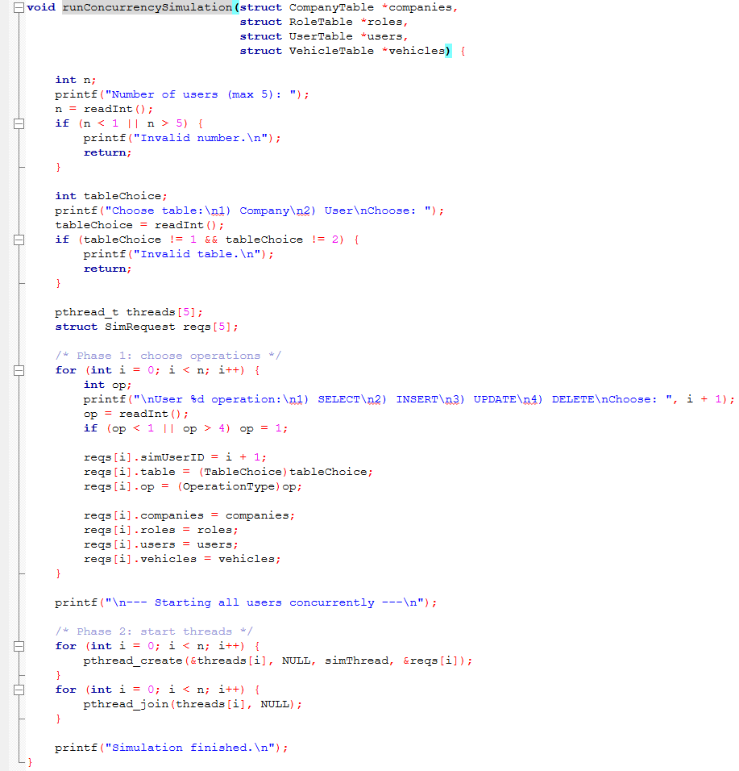
As shown in the image I create up to 5 threads (users) and 5 receives a request structure that has:
- userID (1 to 5).
- Target table.
- Operation type.
- Pointers to the tables in memory.
After the operations are chosen, all threads are started almost at the same time using pthread_create, and the program waits for them to finish using pthread_join.

I used lock-based concurrency control with the shared lock (S) and the exclusive lock (X), the S lock was for select operation since reading does not change on the data, on the contrary the X lock was used for the other operations as they do change on the data. Also my lock is at a table level lock that shuts the full table until the operation is done.
Lock acquisition and release logic
For each table, two acquisition functions exist:
- acquireCompanyS() / acquireUserS()
Grants shared lock if there is no exclusive lock.
It also increments SCount to track how many readers are active.
- acquireCompanyX() / acquireUserX()
Grants exclusive lock only if the lock mode is LOCK_NONE (no active readers or writers).
Locks are released using:
- releaseCompanyS() / releaseUserS() (decrement SCount and release when it becomes 0)
- releaseCompanyX() / releaseUserX() (directly set lock mode to NONE)
To protect lock state from race conditions, each lock acquire/release is guarded by a mutex (pthread_mutex_lock / pthread_mutex_unlock). This ensures that lock state updates are atomic.
Waiting behavior (blocking simulation)
If a lock cannot be granted, the thread prints a waiting message such as:
- User X waits (S lock)
- User X waits (X lock)
Then the thread sleeps for a short time (sleep(1)) and tries again. This is a busy-wait style retry loop, used here mainly for simplicity and to make the simulation output easy to observe.
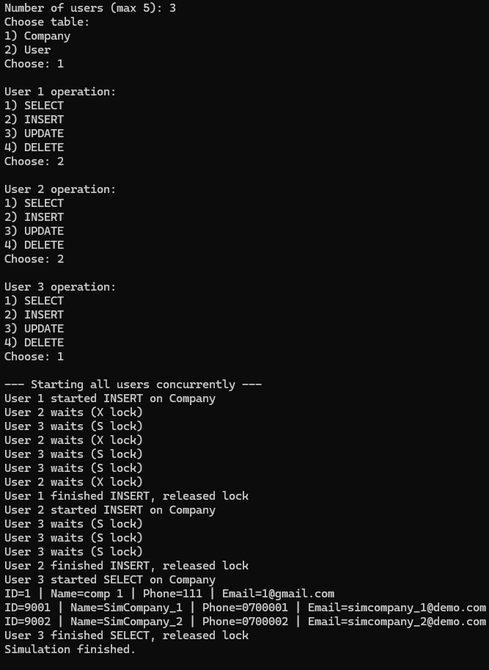

User Interface and Testing Plan

User Interface Development
The developed user interface is a menu-driven command line interface (CLI) that allows an administrator to access and manage all database tables and DBMS functions. The interface is designed to be simple and clear, and it supports full CRUD operations (List, Add, Update, Delete) for all tables in the system. It also provides additional system options such as full backup and a concurrency control demonstration.
The structure of the menu
There is two levels on the menu:
  - The table menu
That has access to all the tables, backup, logs, and CC.
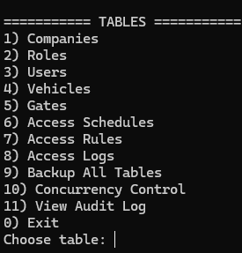

  - The actions menu
This has the access to do the CRUD operations on the tables.
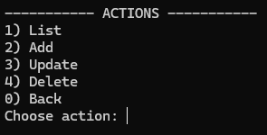
I have 2 helper functions to make the reading the input safer and easier
- Read line
its purpose is to safely read a full line of text from the user and remove the newline at the end.
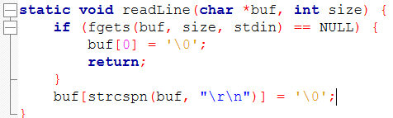
- Read int
its purpose is to read a line of user input and convert it into an integer.
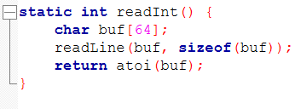
Here is an example of CRUD operations on role table
- Select
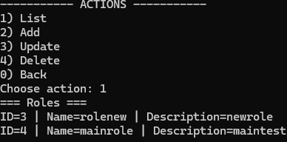
- Insert
This is when the data filled correctly.
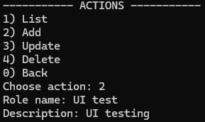
Here the data is not filled correctly (any of the constraints is wrong)
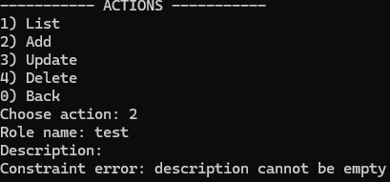
- Update
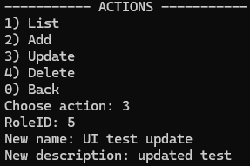
Here is the updated list
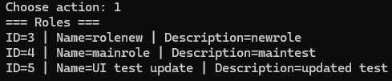
- Delete
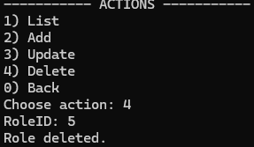
The list after delete
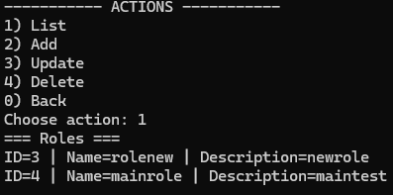
This go for all other tables as they are all the same in the CRUD operations.
Overall the interface is user friendly and consistent with the formatting, has validation on every step and give a feedback massages when needed.

Testing Plan
Test ID | Component Tested | Test Description | Test Steps | Expected Result | Actual Result | Status
T1 | Storage Manager | CSV file creation and loading | Start program with missing CSV files | CSV files are created with headers | Files created correctly | Pass
T2 | Storage Manager | Data persistence after restart | Add records → exit program → restart → list tables | Data still exists after restart | Data loaded correctly | Pass
T3 | Buffer Manager | In-memory CRUD operations | Insert, update, delete records and list table | Correct data shown, no crashes | Operations successful | Pass
T4 | UNIQUE constraint | Duplicate unique field (email/plate) | Insert record with duplicate email/license | Insert rejected | Constraint error shown | Pass
T5 | Foreign Key constraint | Invalid foreign key reference | Insert vehicle with non-existing userID | Insert rejected | FK error shown | Pass
T6 | Referential integrity | RESTRICT delete behavior | Delete parent record with dependent child | Delete blocked | Delete prevented | Pass
T7 | Logging | Audit log generation | Perform INSERT/UPDATE/DELETE | Log entry created | Log recorded | Pass
T8 | User Interface | Menu navigation | Navigate tables/actions, use back/exit | Correct menu behavior | No UI errors | Pass
T9 | Error handling | Invalid input handling | Enter invalid menu options | Error message shown | Error handled | Pass
T10 | Concurrency Control | Shared locks (S) | Run multiple SELECT threads | All SELECTs run together | Correct behavior | Pass
T11 | Concurrency Control | Exclusive lock (X) | Run UPDATE with SELECT active | UPDATE waits | Wait message shown | Pass
T12 | Concurrency Control | Writer–writer conflict | Run two UPDATE threads | One waits, one executes | Lock enforced | Pass
T13 | Backup | Full database backup | Use “Backup All Tables” option | Backup files created | Backup successful | Pass

Screen shot proofs
T1.
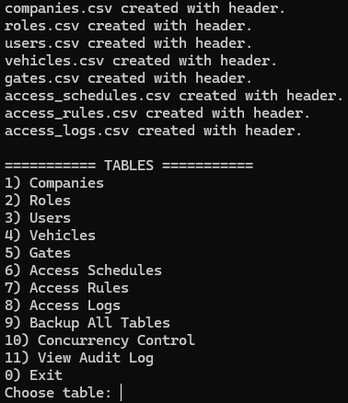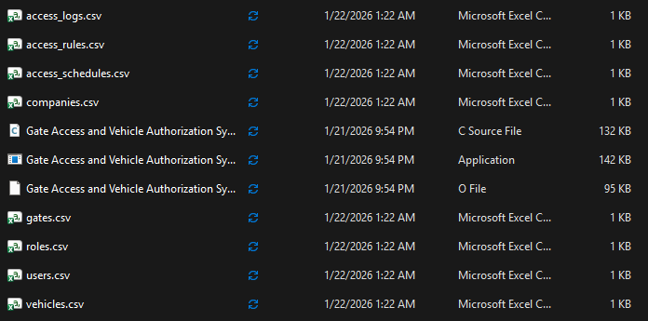
T2.
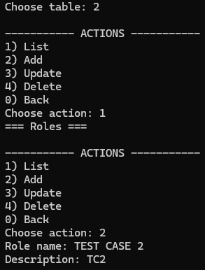
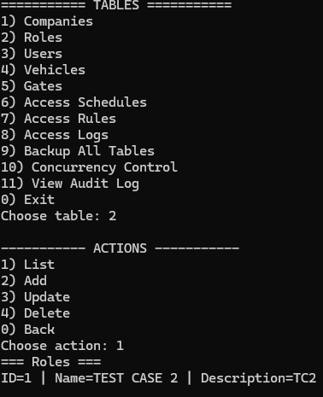
T3.
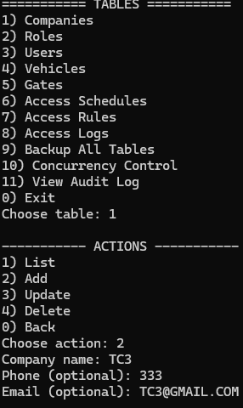
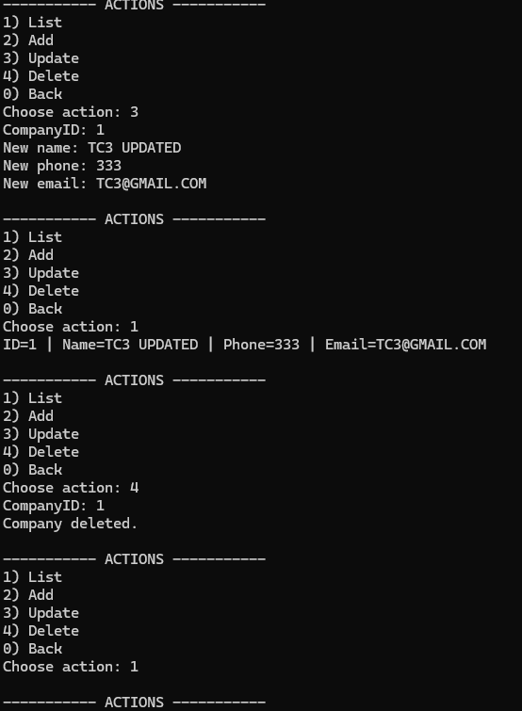
T4.
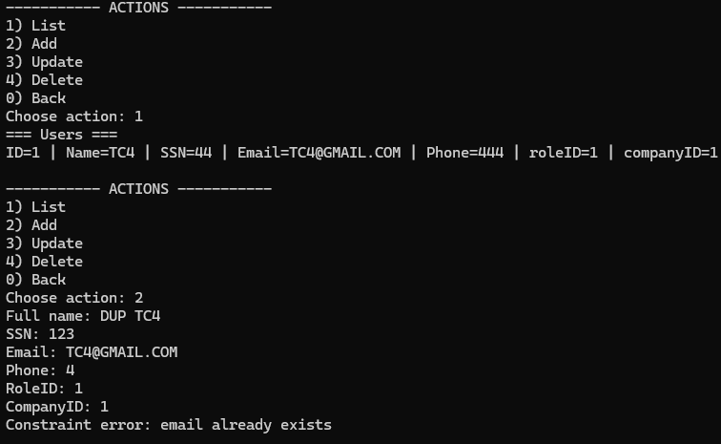
T5.
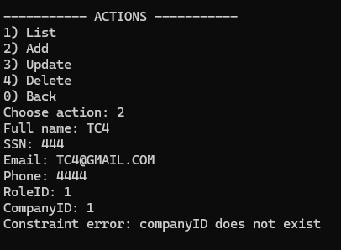
T6.
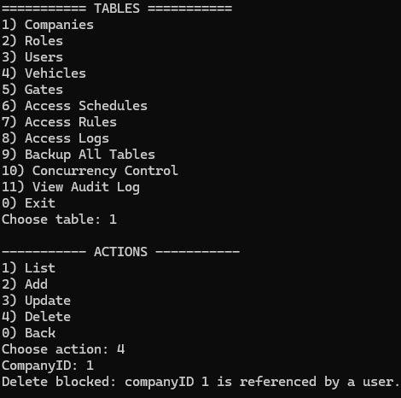
T.7
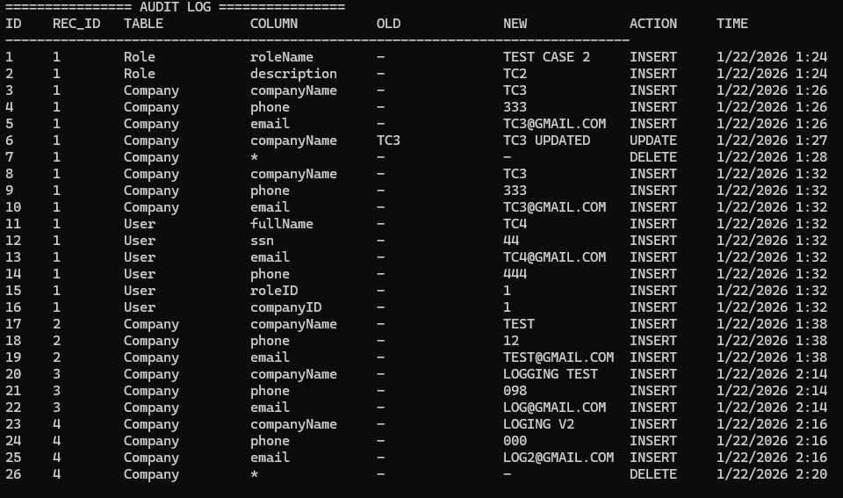
T8.
Images shown on all other test cases
T9.
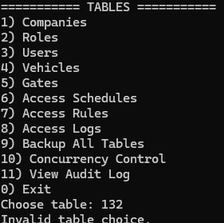
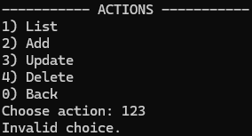
T10 & 11 & 12.
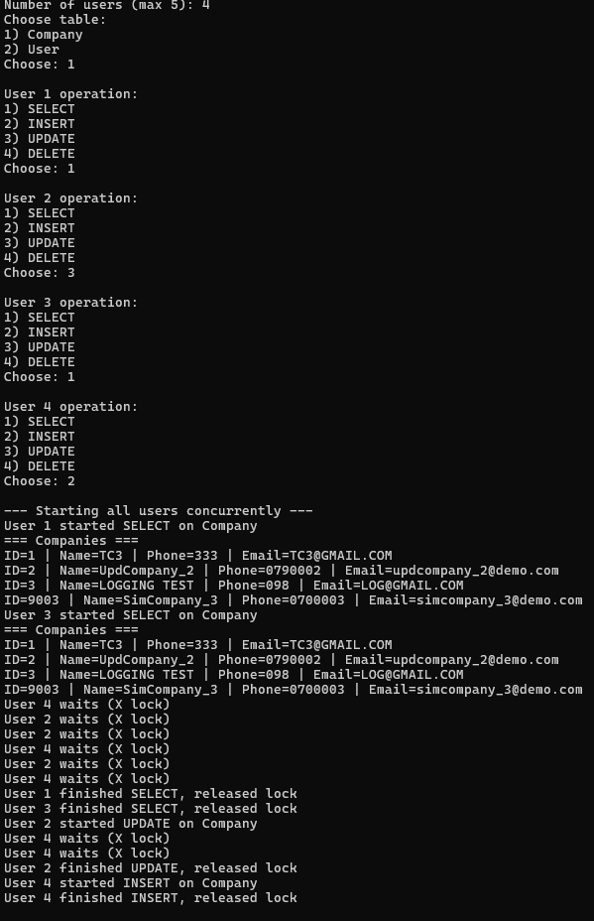
T13.
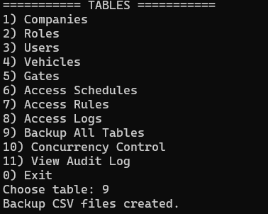
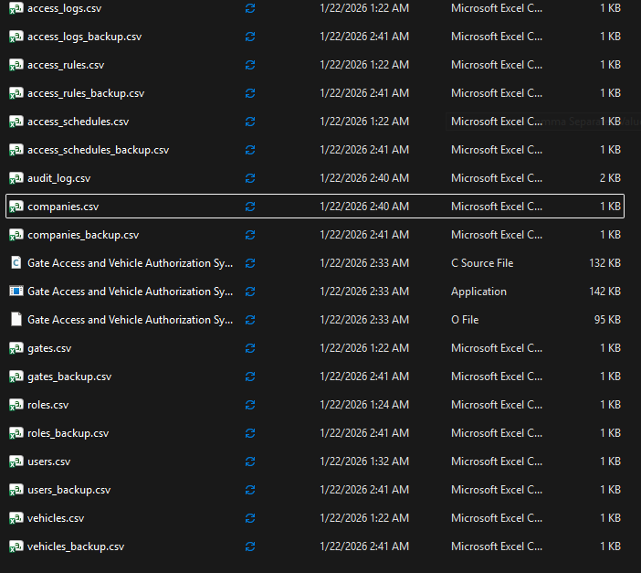

Evaluation
Even though the developed DBMS works correctly for the scope of this project, there are several improvements needed to make sure it stays effective if the database grows or is used in a more realistic environment. Some of the current design choices are simple and safe, but they also create limitations over time.
A major concern is the handling of updates and deletes in storage. When a record is modified or erased, the system will rewrite the whole CSV file of that table. This is alright with small tables but it becomes inefficient with large data. All the rows are rewritten to disk even with a single row modified. In an actual DBMS, updates are normally made per page or record rather than rewriting the entire dataset. To enhance this, the system might make use of page-based storage or binary file format where the part that is changed is written back and this would significantly improve the performance. Also the update operation requires to fill the full information about the row you want to up date this makes it annoying and inflexible if you want to change one column only.
The other weakness is associated with query flexibility. The existing system is predominantly unsuitable to the extent of the simplest type of query and the only SELECT command that is supported is the listing of all records in a table. It does not allow searching using the ID, filtering using certain fields and using multiple conditions. More advanced SQL queries which include joins of tables or conditional search are not supported at all. As a case in point, such queries as retrieving vehicles along with their user names and roles, or filtering access logs by date range or gate cannot be executed without writing new functions manually. Even the ability to support conditional queries or simple joins would make the DBMS more flexible and more of what real SQL systems are.
The system also does not have the appropriate rollback feature in case of an issue that occurs in one query. Currently, in case one part of an operation is not working after some changes have been implemented there is no automatic mechanism of undoing changes. In actual DBMS, it is possible to roll back transactions and bring the database to a former consistent state. Enhancing the consistency of the database by adding rollback capability based on log records would help avoid the inconsistent state of the database following a partial update.
Another limitation of the current system is the way concurrency control is handled. The DBMS uses table-level shared and exclusive locks, which is simple and easy to understand, but it also limits how much parallel work can be done. When one user is updating a table, all other users must wait, even if they want to access a different record in the same table. In real DBMS systems, concurrency control is usually done at a finer level, such as record-level locking, which allows more users to work at the same time without unnecessary blocking. Also, the waiting mechanism in this system is based on repeated checking and sleeping, rather than proper scheduling or condition variables. It would not scale well in a real multi-user environment. Improving concurrency control by using record-level locks and more advanced lock management would make the system more efficient and closer to real database behaviour.
Comprehensively, a DBMS performance with regards to its ability to maintain itself as data size, complexity of its use as well as the number of people who can use it increases. Although a simple DBMS structure may operate reasonably in a controlled or small scale setting, over time, more sophisticated storage, querying, transactions and concurrency control is needed. Ineffective update mechanisms, weak expressiveness of queries, absence of rollback, and coarse-grained concurrency control may also prove to be a severe draw upon as demands increase. A DBMS that is to be effective has to be able to maintain efficient data modification, flexible query processing, reliable transaction recovery and fine-grained concurrency control. The consideration of these factors is ultimately needed to provide scalability, consistency, and reliability in practical database systems.

References
GeeksforGeeks (2018). Query Processing in SQL. [online] GeeksforGeeks. Available at: https://www.geeksforgeeks.org/sql/sql-query-processing/.
‌
https://www.slideserve.com/aechevarria/overview-of-a-database-management-system-powerpoint-ppt-presentation

